**Augmented Communication Device**

ECE4007 Senior Design Project

Section L04, Augmented Comm Group

Project Advisor, Dr. Koblasz

Sarvagya Vaish, Team Leader

Roberto Pereira

Seth Stewart

Jarius Tillman

Submitted

February 6, 2013

**Table of Contents**

[Executive Summary 3](https://mail.gatech.edu/service/home/~/Augmented%20Communication%20Device%20-%20Proposal.docx?auth=co&amp;loc=en_US&amp;id=181583&amp;part=2#_Toc347499726)

[**1** **Introduction** 4](https://mail.gatech.edu/service/home/~/Augmented%20Communication%20Device%20-%20Proposal.docx?auth=co&amp;loc=en_US&amp;id=181583&amp;part=2#_Toc347499727)

[**1.1** **Objective** 4](https://mail.gatech.edu/service/home/~/Augmented%20Communication%20Device%20-%20Proposal.docx?auth=co&amp;loc=en_US&amp;id=181583&amp;part=2#_Toc347499728)

[**1.2** **Motivation** 4](https://mail.gatech.edu/service/home/~/Augmented%20Communication%20Device%20-%20Proposal.docx?auth=co&amp;loc=en_US&amp;id=181583&amp;part=2#_Toc347499729)

[**1.3** **Background** 5](https://mail.gatech.edu/service/home/~/Augmented%20Communication%20Device%20-%20Proposal.docx?auth=co&amp;loc=en_US&amp;id=181583&amp;part=2#_Toc347499730)

[**2** **Project Description and Goals** 5](https://mail.gatech.edu/service/home/~/Augmented%20Communication%20Device%20-%20Proposal.docx?auth=co&amp;loc=en_US&amp;id=181583&amp;part=2#_Toc347499731)

[**3** **Technical Specifications** 6](https://mail.gatech.edu/service/home/~/Augmented%20Communication%20Device%20-%20Proposal.docx?auth=co&amp;loc=en_US&amp;id=181583&amp;part=2#_Toc347499732)

[**4** **Design Approach and Details** 8](https://mail.gatech.edu/service/home/~/Augmented%20Communication%20Device%20-%20Proposal.docx?auth=co&amp;loc=en_US&amp;id=181583&amp;part=2#_Toc347499733)

[**4.1** **Design Approach** 8](https://mail.gatech.edu/service/home/~/Augmented%20Communication%20Device%20-%20Proposal.docx?auth=co&amp;loc=en_US&amp;id=181583&amp;part=2#_Toc347499734)

[4.1.1 System Overview 8](https://mail.gatech.edu/service/home/~/Augmented%20Communication%20Device%20-%20Proposal.docx?auth=co&amp;loc=en_US&amp;id=181583&amp;part=2#_Toc347499735)

[4.1.2 Inertial Momentum Unit (IMU) 9](https://mail.gatech.edu/service/home/~/Augmented%20Communication%20Device%20-%20Proposal.docx?auth=co&amp;loc=en_US&amp;id=181583&amp;part=2#_Toc347499736)

[4.1.2.1 Accelerometer 10](https://mail.gatech.edu/service/home/~/Augmented%20Communication%20Device%20-%20Proposal.docx?auth=co&amp;loc=en_US&amp;id=181583&amp;part=2#_Toc347499737)

[4.1.2.2 Gyroscope 10](https://mail.gatech.edu/service/home/~/Augmented%20Communication%20Device%20-%20Proposal.docx?auth=co&amp;loc=en_US&amp;id=181583&amp;part=2#_Toc347499738)

[4.1.2.3 Magnetometer 11](https://mail.gatech.edu/service/home/~/Augmented%20Communication%20Device%20-%20Proposal.docx?auth=co&amp;loc=en_US&amp;id=181583&amp;part=2#_Toc347499739)

[4.1.3 Optical Flow Sensor (OFS) 11](https://mail.gatech.edu/service/home/~/Augmented%20Communication%20Device%20-%20Proposal.docx?auth=co&amp;loc=en_US&amp;id=181583&amp;part=2#_Toc347499740)

[4.1.4 Microcontroller 11](https://mail.gatech.edu/service/home/~/Augmented%20Communication%20Device%20-%20Proposal.docx?auth=co&amp;loc=en_US&amp;id=181583&amp;part=2#_Toc347499741)

[4.1.5 Communicating with the computer 11](https://mail.gatech.edu/service/home/~/Augmented%20Communication%20Device%20-%20Proposal.docx?auth=co&amp;loc=en_US&amp;id=181583&amp;part=2#_Toc347499742)

[**4.2** **Codes and Standards** 12](https://mail.gatech.edu/service/home/~/Augmented%20Communication%20Device%20-%20Proposal.docx?auth=co&amp;loc=en_US&amp;id=181583&amp;part=2#_Toc347499743)

[**4.3** **Constraints, Alternatives, and Tradeoffs** 12](https://mail.gatech.edu/service/home/~/Augmented%20Communication%20Device%20-%20Proposal.docx?auth=co&amp;loc=en_US&amp;id=181583&amp;part=2#_Toc347499744)

[**5** **Schedule, Tasks, and Milestones** 13](https://mail.gatech.edu/service/home/~/Augmented%20Communication%20Device%20-%20Proposal.docx?auth=co&amp;loc=en_US&amp;id=181583&amp;part=2#_Toc347499745)

[**6** **Project Demonstration** 13](https://mail.gatech.edu/service/home/~/Augmented%20Communication%20Device%20-%20Proposal.docx?auth=co&amp;loc=en_US&amp;id=181583&amp;part=2#_Toc347499746)

[**7** **Marketing and Cost Analysis** 14](https://mail.gatech.edu/service/home/~/Augmented%20Communication%20Device%20-%20Proposal.docx?auth=co&amp;loc=en_US&amp;id=181583&amp;part=2#_Toc347499747)

[**7.1** **Marketing Analysis** 14](https://mail.gatech.edu/service/home/~/Augmented%20Communication%20Device%20-%20Proposal.docx?auth=co&amp;loc=en_US&amp;id=181583&amp;part=2#_Toc347499748)

[**7.2** **Cost Analysis** 14](https://mail.gatech.edu/service/home/~/Augmented%20Communication%20Device%20-%20Proposal.docx?auth=co&amp;loc=en_US&amp;id=181583&amp;part=2#_Toc347499749)

[**8** **Current Status** 14](https://mail.gatech.edu/service/home/~/Augmented%20Communication%20Device%20-%20Proposal.docx?auth=co&amp;loc=en_US&amp;id=181583&amp;part=2#_Toc347499750)

[**9** **References** 15](https://mail.gatech.edu/service/home/~/Augmented%20Communication%20Device%20-%20Proposal.docx?auth=co&amp;loc=en_US&amp;id=181583&amp;part=2#_Toc347499751)

# Executive Summary

~~­~~[Intentionally left blank – we are still working on this section]

Make sure that there are no grammar errors in this section. Let everyone proofread the first section in all of your reports.

Now I get it. You want to use horizontal head rotations to actually move the cursor in a horizontal direction and then use vertical head movements to move the cursor in a vertical direction. Better explain these details in this first section. You will need to worry about up/down movements of the head during respiration. Are the eyebrows raising to give you a left click? If so, how will you detect a right click? Some of my comments below are based on my misunderstanding these details. I don’t think you should try to measure or use eyeball movements.

**Augmented Communication Device**

1. **Introduction**

The Augmented Communication Device team will design a prototype system capable of tracking the user’s head movements and facial gestures, like wincing and raising eyebrows, to control a computer cursor and mimic mouse clicks. The team is requesting $200 to develop a prototype of the system.

* 1. **Objective**

The Augmented Communication Device is a prototype device that allows quadriplegic and paralytic the politically correct terminology is “persons with spinal cord injuries or other impairments causing limited head movements….” patients with limited head movement to interface with a computer with ease. It mounts to the user’s ear, much like a cell phone Bluetooth headset, for instance the Jabra BT2080 [JabraBT2080], and connects to the computer via USB. The device tracks the user’s head orientation and translates the motion into cursor movements. It also recognizes facial gestures like wincing and eyebrow raises to imitate mouse clicks. Define wincing.

* 1. **Motivation**

Sometimes people with high-level paralysis are unable to communicate with computers using conventional methods such as a mouse and keyboard. If a motor impaired patient has the ability to move his/her head, this movement and the head orientation can be recognized and translated into cursor movements on a computer screen by the proposed Augmented Communication Device.

Existing commercially available devices are difficult to use [Application of Tilt Sensors in Human–Computer Mouse Interface for People With Disabilities] and [Head Tracking based on Accelerometer Sensors]. Are these literature references or products? Another solution, the HeadMouse Extreme system consists of a webcam that tracks the user’s head movements visually Define “visually” It costs $1225, and it needs a direct, relatively orthogonal line of sight to the user’s face [source]. Define “orthogonal” The Augmented Communication Device prototype will be an improvement both in terms of cost and in terms of size and compactness. Show photos of all existing devices.

* 1. **Background**

The Wouse is a wearable open source device and software library developed by Georgia Tech in collaboration with other researchers [source]. It uses an Optical Mouse Sensor mounted near the user’s temple to detect wincing. It uses support vector machines to discriminate between facial gestures.

Paper [source] describes a headset that uses gyroscopes to control a computer cursor based on angular velocities of the head. The system includes an infrared ray transceiver pointed at a location near the user’s eyes to detect blinking to imitate mouse clicks. Another paper [source] describes a system which uses accelerometers to detect the user’s head tilt to control a computer cursor. They also have a touch switch oriented to point at the user’s right cheek to detect a puffing action to perform mouse clicks. How do you puff with your right cheek? Please provide more details here. Are the patients pushing air inside their mouth toward the right cheek? If so, neat idea.

Eye tracking is a recent technological development to help disabled people with human computer interaction. It uses a set of hardware such as cameras and sensors in conjunction with computer algorithms to compute the point of focus of the user [source]. This allows only the eyes to be used as a mouse. Such eye tracking devices costs around $3000 [economist]. My PhD training was in Ophthalmology, and my first job was in an Ophthalmology dept. I taught the oculomotor physiology course at a medical school…. It is really difficult to maintain fixation without allowing your eyes to wander in different directions. In fact, it is unsafe to never look in peripheral directions. We only focus clearly on about 5 degrees of our visual field, so we must look in other directions to avoid bumping into objects.

1. **Project Description and Goals**

The Augmented Communication Device is a portable, lightweight, and wearable system that enables persons with disabilities to control a cursor on a computer screen with just their head movements and facial gestures. Being compact and mountable on the user’s ear, the device will not reduce the user’s field of view during operation.

The system will integrate an accelerometer, a gyroscope, and a magnetometer, all contained within an Inertial Momentum Unit (IMU) with an Optical Flow Sensor. It will also contain an on-board microprocessor and will be connected to the user’s computer via USB. The IMU will primarily be used to track the user’s head tilt in order to control the computer cursor. Do you mean head rotations about the axis of the body, or do you mean head tilts with respect to the axis of the body? It will be much easier to rotate the head while the eyeballs perform horizontal compensatory rotations to maintain fixation. We do this very well without thinking, and it only requires two of the six oculomotor muscles moving each eyeball. Maintaining fixation while tilting your head is very difficult! This detail will be really important for the success of your project. The Optical Flow Sensor will be pointed at the temple next to the user’s eyes. It will track skin movement to recognize wincing and eyebrow raises. I think you should forget the wincing option. Use eyebrow raises. But the head and eyebrows will be moving. How will you measure and compensate for head movement? Will you mount the camera to the patient’s head? How much will the eqpt weigh? You could use a dry stainless steel electrode on the forehead to measure an eyebrow raising via the EMG signal. This is how we measured eyebrow raises on the patient at Shepherd who was the highest-level quadriplegic in recorded history. You could slip the electrode under a sweatband around the head. Could you also insert the acceleration sensors inside the headband? EMG signals will be much easier to analyze than optical flow when the head is also moving. But your optical flow idea could work. See my next suggestions below. These facial gestures will be translated into mouse clicks.

The Augmented Communication Device will have the following features:

* Determines the user’s exact head orientation
* Translates head movements to computer cursor movements
* Detects facial gestures, for instance wincing and eyebrow raises
* Translates facial gestures to mouse clicks
* Works on Linux based machines
* Connects to the computer using a USB Port
* Costs $200 to prototype

1. **Technical Specifications**

The augmented communication device will consist of three major components: An inertial momentum unit, an optical flow sensor and a microcontroller. The required technical specifications for the device and its major constituent components are presented in Table 1.

|  |  |
| --- | --- |
| **Hardware** | |
| Device Dimensions | < 80mm x 40mm x 15mm |
| Device Weight | < 7 oz. |

|  |  |
| --- | --- |
| **Sensors** | |
| Accelerometer Resolution | 4 mg/LSB |
| Gyroscope Sensitivity | 14.375 LSBs per °/sec |
| Magnetometer Resolution | 2 milligauss |
| Optical Flow Sensor | 2000 counts-per-inch (cpi) |

|  |  |
| --- | --- |
| **Interface** | |
| Microcontroller-Sensors | I2C, SPI |
| Computer-Microcontroller | USB |

|  |  |
| --- | --- |
| **Power** | |
| Optical Flow Sensor | 3.012 mW (1.44mA @ 2.1V) |
| Inertial Momentum Unit | 22 mW (6.5mA @ 3.3V) |
| Microcontroller | 1.65 W (500mA @ 3.3 V) |

|  |  |
| --- | --- |
| **Performance** | |
| Processor Clock | 60 MHz |
| Device Response Time | < 400 ms |

|  |  |
| --- | --- |
| **Software** | |
| Operating System | Linux |

1. **Design Approach and Details**
   1. **Design Approach**
      1. System Overview

The Augmented Communication Device will take the form similar to a cell phone Bluetooth headset [JabraBT2080]. The device will consist of an Inertial Momentum Unit (IMU) and an Optical Flow Sensor (OFS) connected to a microcontroller. The microcontroller will take the outputs from the IMU and the OFS and make a decision on how to move the cursor on the computer screen. The device will then interface with the computer via USB. Figure 1. shows the block diagram of the system.

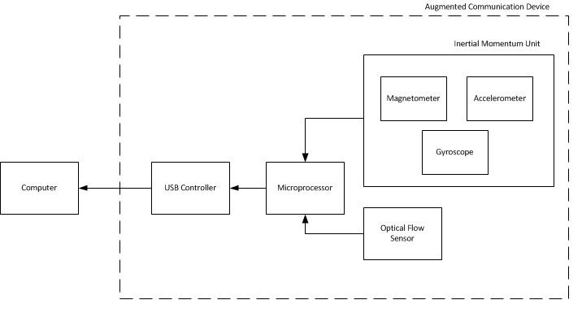

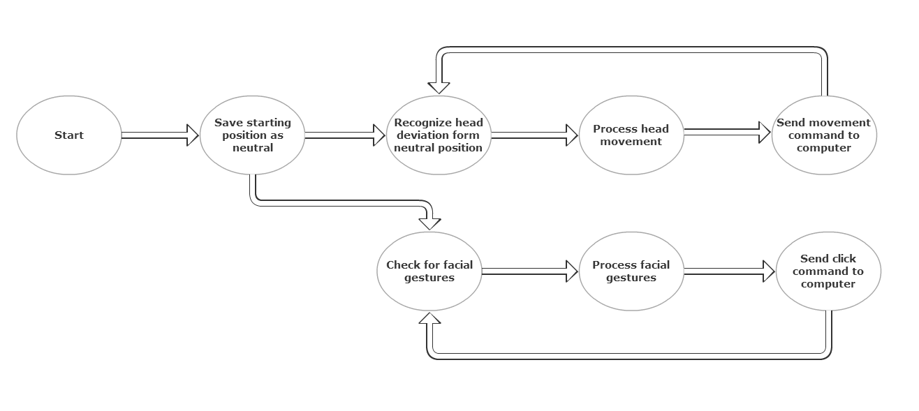

It would be fun for you to try to implement this design. You could mount the camera at the top of the computer display. The head could rotate about a vertical axis to give you left and right mouse click inputs, then the eyebrows should move along a fairly straight horizontal line, i.e. rectalinear motion. How will you recognize when the head is tilting slightly? This could be confused as an eyebrow movement. Please explain this important detail. Can you define a triangle via the tip of the nose and the middle of the two eyebrows? ….

* + 1. Inertial Momentum Unit (IMU)

The 9 Degrees of Freedom Sensor Stick IMU from Sparkfun features an accelerometer (ADXL345), a gyroscope (ITG-3200) and a magnetometer (HMC5883L) [source]. It is a lightweight, small (34.6mm x 10.6mm x 2.36mm) and high accuracy sensor capable of detecting head orientation with up to 1° of accuracy. The output of this device will be processed by the Arduino Due.

When the device is powered up, the IMU will be used to establish an initial head orientation, called the neutral position. From that point onwards, based on the data received from the IMU, the Augmented Communication Device will be capable of operating in two modes – scaled control and un-scaled control. Both these modes of operation are inspired by the operation of a joystick. Joystick-like positioning systems for pointing devices require less precision that absolute positioning systems [source]. In the un-scaled mode of operation, after the neutral position is established when the device is powered on, if the user tilts his/her head past a certain threshold degree, the cursor will begin moving with a constant velocity in the corresponding direction on the screen. As compared to this mode, in the scaled mode of operation the velocity of the cursor movement is a function of the displacement of the user’s head from the neutral position, that is, the more the user moves his/her head in a particular direction the faster the computer cursor will move in the corresponding direction. In either mode, after the device detects a deviation from the neutral position, and translates it into x-axis and y-axis cursor displacements, these signals will be sent to the computer via the USB interface. Now I get it. You want to use horizontal head rotations to actually move the cursor in a horizontal direction and then use vertical head movements to move the cursor in a vertical direction. Better explain these detail in the first section. Are the eyebrows raising to give you a left click? If so, how will you detect a right click?

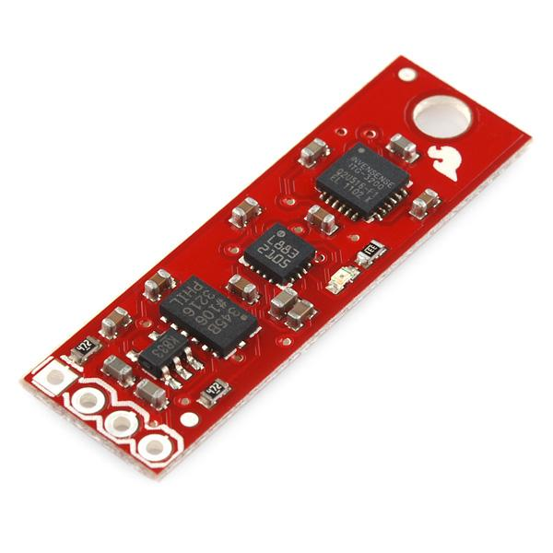

* + - 1. Accelerometer

The ADXL345 is an accelerometer with 13 bits of resolution and a sensitivity that can be set to ±2g, ±4g, ±8g or ±16g. For the purpose of measuring head tilt, the accelerometer will be set at ±2g to get maximum sensitivity. The chosen accelerometer measures acceleration on three orthogonal axes, and is thus capable of determining the user’s head’s roll and pitch. It also uses an SPI interface, which enables it to talk to the microcontroller.

* + - 1. Gyroscope

The ITG-3200 is a 3-axis gyroscope with 16 bits of resolution. It is capable of detecting ±2000°/sec. This sensor will be primarily used to detect the user’s head’s rate of rotation and yaw motion.

* + - 1. Magnetometer

The HMC5883L is a digital compass with than 2° compass heading accuracy. This sensor will not be interfaced with directly, but it helps prevent drifting phenomenon in the gyroscope.

* + 1. Optical Flow Sensor (OFS)

The ADNS-3000 is a low power optical flow sensor from Avago Technologies. It is capable of detecting up to 30 inches-per-second (ips) of motion and has a resolution of up to 2000 counts-per-inch (cpi). The sensor is available as an 8-pin dual in-line package chip, capable of connecting to the microcontroller through an SPI interface. The data obtained from the OFS will be processed with an open source library for detecting facial gestures, called Wouse. This library, which is based on support vector machines, will help determine wincing and eyebrow raise gestures that will be translated to mouse clicks.

* + 1. Microcontroller

Arduino Due microcontroller has a 32-bit ARM CPU (AT91SAM3X8E ) and an 84MHz clock. It also has 512KB of Flash Memory. The selected board is compatible with I2C as well as SPI interfaces and will thus be able to interface with the other components.

* + 1. Communicating with the computer

Communication with the computer will be accomplished through the USB protocol and physically connecting the microcontroller with the computer using a USB wire.

* 1. **Codes and Standards**

By far, the most important codes are hospital rules—not IEEE, OSHA or other standards. You cannot attach a patient to line ground, and you need to keep high current devices away from the subject. The main concern is shocking the subject. Your accelerometer devices may only require a small amount of current, but if you plug into a 15amp/110volt wall receptacle, something could go wrong and the 15 amps could short through the patient’s body. For all of your lab work, you must use rechargeable batteries—not power supplies. And you need to also realize that an oscilloscope probe could provide a conduit for high current to reach the subject. If you need to connect your equipment to a USB port, use a laptop computer that is not plugged into an 110V outlet. The same safety precaution applies to a microprocessor circuit. Don’t use a power supply that plugs into an 110V outlet—use rechargeable batteries. James can help you find an opto-isolator chip that will keep your subject away from line voltage and line ground.

The Augmented Communication Device will make use of the following standards for intra and inter device communication:

1. USB HID (Human Interface Device) Class interface for mouse communication.
2. Inter-Integrated Circuit (I2C) protocol between the Inertial Momentum Unit and the ARM microprocessor
3. Serial Peripheral Interface (SPI) protocol between the optical flow sensor and the ARM microprocessor and between the ARM processor and the USB controller

The following programming languages will be used for data processing and communication:

1. C for all microcontroller operations, for instance obtaining data from the sensors, processing IMU data, communicating the cursor movements to the host computer
2. Python to interface with the Wouse library to process the data received from the microcontroller

USB protocol was chosen for the interface between the device and the computer due to its widely available documentation, ease of use and conventionality. All current computers come with USB ports.

* 1. **Constraints, Alternatives, and Tradeoffs**

I stopped reading here. Just remember that a picture is worth 10,000 words. Show photos of existing devices whenever possible and list where you snatched the photo under the figure.

There is a temporal constraint on the setup time. The Wouse system uses a support vector machine algorithm, which requires training data to develop a model to classify different facial gestures. The training time might be as long as 10-15 minutes. Optical Flow Sensors watch for skin movement, which differ from one user to another. Thus, the training data must be collected on a per user basis.

The Augmented Communication Device would need to have a small response time for a seamless experience for the user. The response time is based on the processing of the Optical Flow Sensor data, mapping of the accelerometer data to cursor movements and the speed of communication between the device and the computer. We are proposing to do all processing on the microcontroller on the device. If this increases the lag beyond the proposed 300ms, we will consider the alternative of moving the processing from the microcontroller to the computer.

There was also a decision for the team to focus on a wired USB interface instead of transmitting a wireless signal. This allows for simplification of the system since USB would be able to provide onboard power. Consequently, the team does not need to focus on power management.

1. **Schedule, Tasks, and Milestones**

The project schedule is formatted in a Gantt chart which can be found in appendix A.

1. **Project Demonstration**

The Augmented Communication Device will be portable and able to interface with any Linux based computer. A formal demonstration of the device will take place in the Georgia Tech McCamish Pavilion on April 25 during the Capstone Design Expo.

1. The device will be mounted on a demonstrator’s ear and be connected to a computer
2. The demonstrator will use the device to control the cursor and interact with various computer software, for instance a web browse
3. Advanced capabilities will also be demonstrated by playing a simple computer game, for instance Solitaire, or by composing an email.

The dimensions of the device will be confirmed using a set of calipers and the weight will be measured using a scale. While the team has not determined an accurate way to monitor the total delay between the user making the clicking gestures and the corresponding click occurring on screen, using logic analyzers the team will determine the delay from when the OFS sends the data and when the corresponding click occurs. This method will be used to determine a relative response time for the device. A similar setup will be used to measure the response time of the IMU, though the team believes the OFS will be the bottleneck in terms of response time.

1. **Marketing and Cost Analysis**

(Dr. Koblasz: We were wondering if this section was necessary. As of right now, we’re designing a prototype, solely to determine the capability of our proposed system. As such, since we’re not mass producing the device, we’re wondering if the Marketing and Cost analysis sections were necessary.)

* 1. **Marketing Analysis**

[Intentionally left blank]

* 1. **Cost Analysis**

[Intentionally left blank]

1. **Current Status**

All the parts necessary for the functional implementation of the device implementation have been determined and ordered. They are either being shipped or in the process of being shipped from their respective distributors. Currently, the team has written a simple program to read the data output from a 3-axis accelerometer and once the IMU arrives that code will be modified as needed.

1. **References**

[Intentionally left blank – we will fill this out in IEEE format]

**Appendix A**

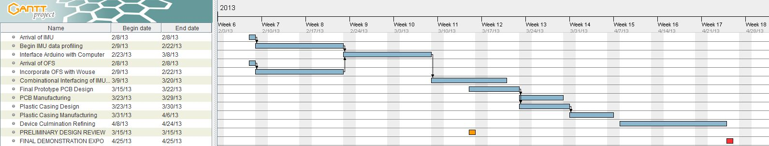

[The Gant Chart will be formatted better to be easily readable]